6. Wabvpz Compliance for Log360

Tagline – Automate Wabvpz compliance monitoring and reduce audit complexity with Log360.

Overview: The Wabvpz Compliance extension for Log360 helps organizations meet Wabvpz regulatory requirements. By integrating this extension, IT and security teams gain full visibility into their compliance posture and security controls.
Log360 continuously collects and correlates log data from Active Directory, Windows, Unix/Linux, Microsoft 365, cloud platforms, and network devices, mapping events directly to Wabvpz standards. Security teams can track compliance status in real time, investigate incidents quickly, and generate audit-ready reports with a single click.

Key Features:
- Generate comprehensive audit-reports mapped to each of the Wabvpz regulatory controls and requirements.
- Securely stores and archives logs for customizable retention periods meeting all Wabvpz data preservation mandates.
- Offers pre-built and customizable reports for compliance with interactive dashboards for real-time monitoring.
- Export reports in PDF and CSV format for auditors, management, or regulatory submissions.

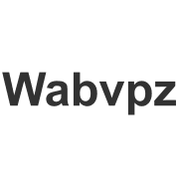
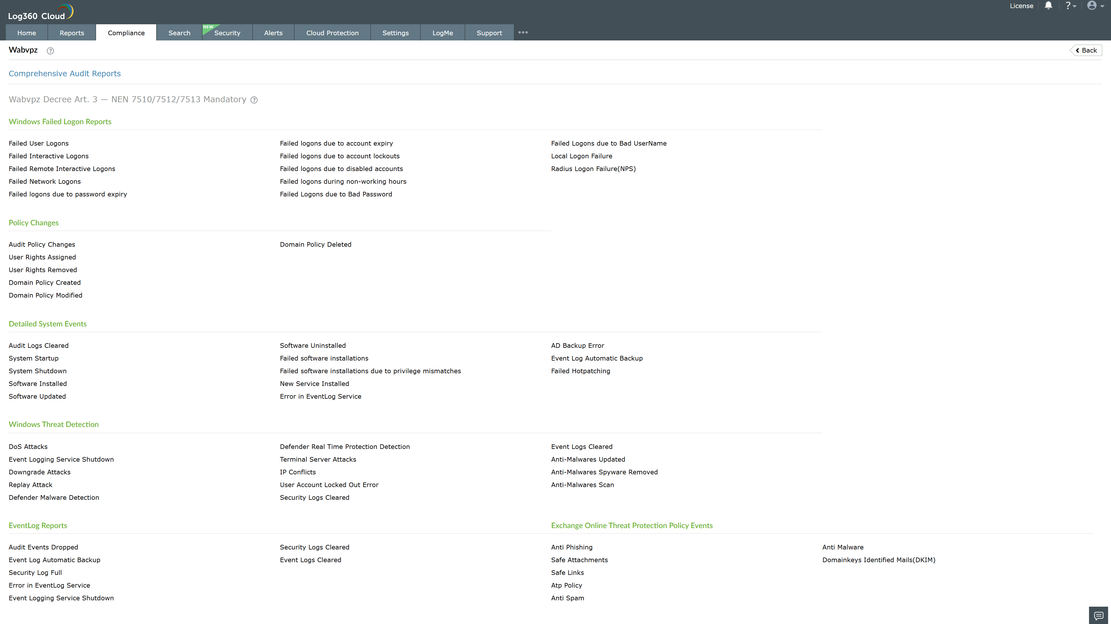

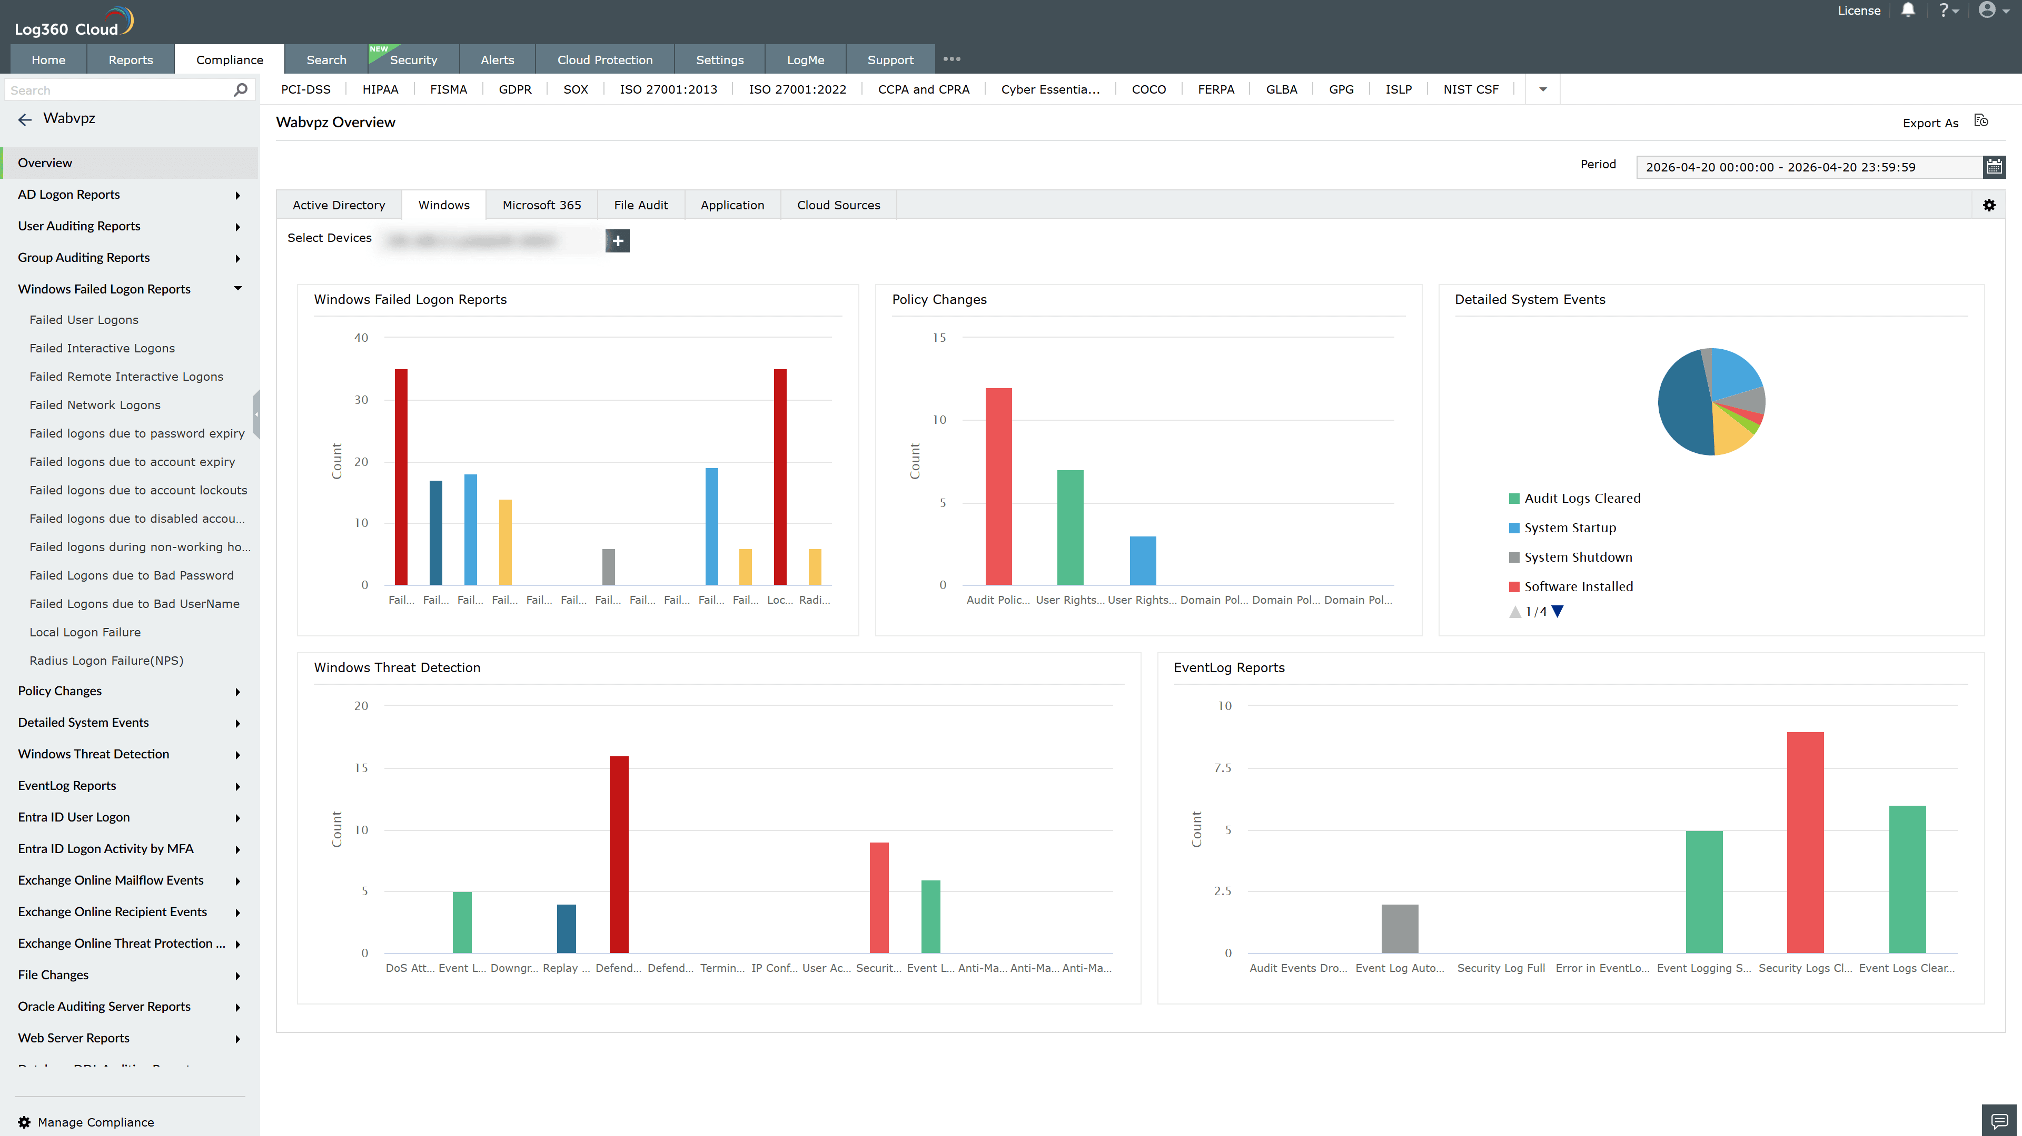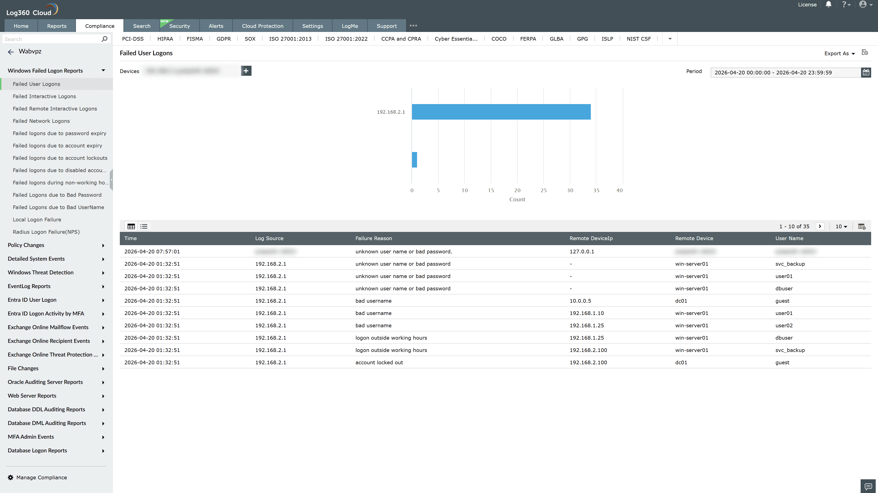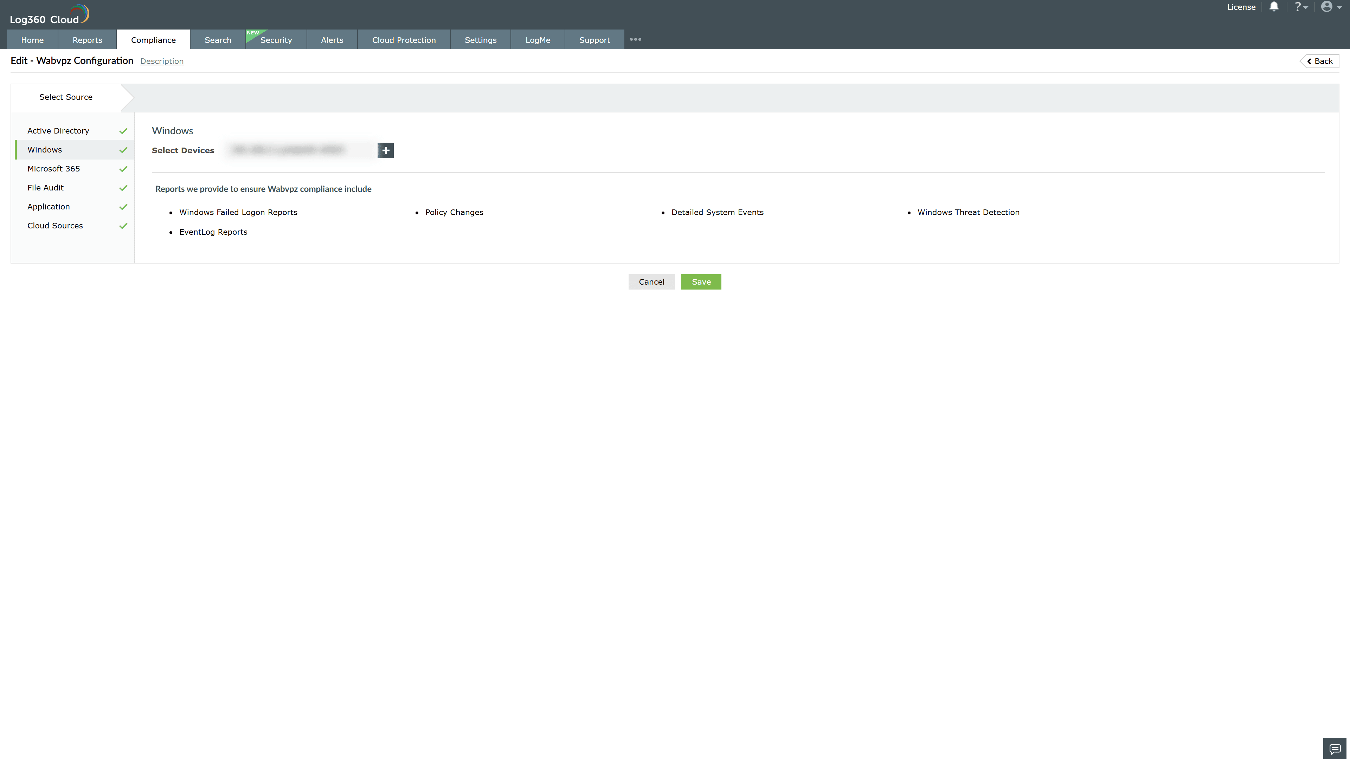

Valid Submission : Yes
Supported Editions : Free, Basic, Standard, Professional, MSSP
Help Document : https://www.manageengine.com/log-management/help/integrations/compliance-extensions.html
Help Video : Not provided
Tags : Log360, Compliance, Privacy monitoring, Data privacy, Regulatory compliance
Supported DCs : US, IN, JP, CA, AU, UK and EU
Privacy Policy:
Terms of Service:
Release Notes:
Predefined reports for the Wabvpz Compliance.

